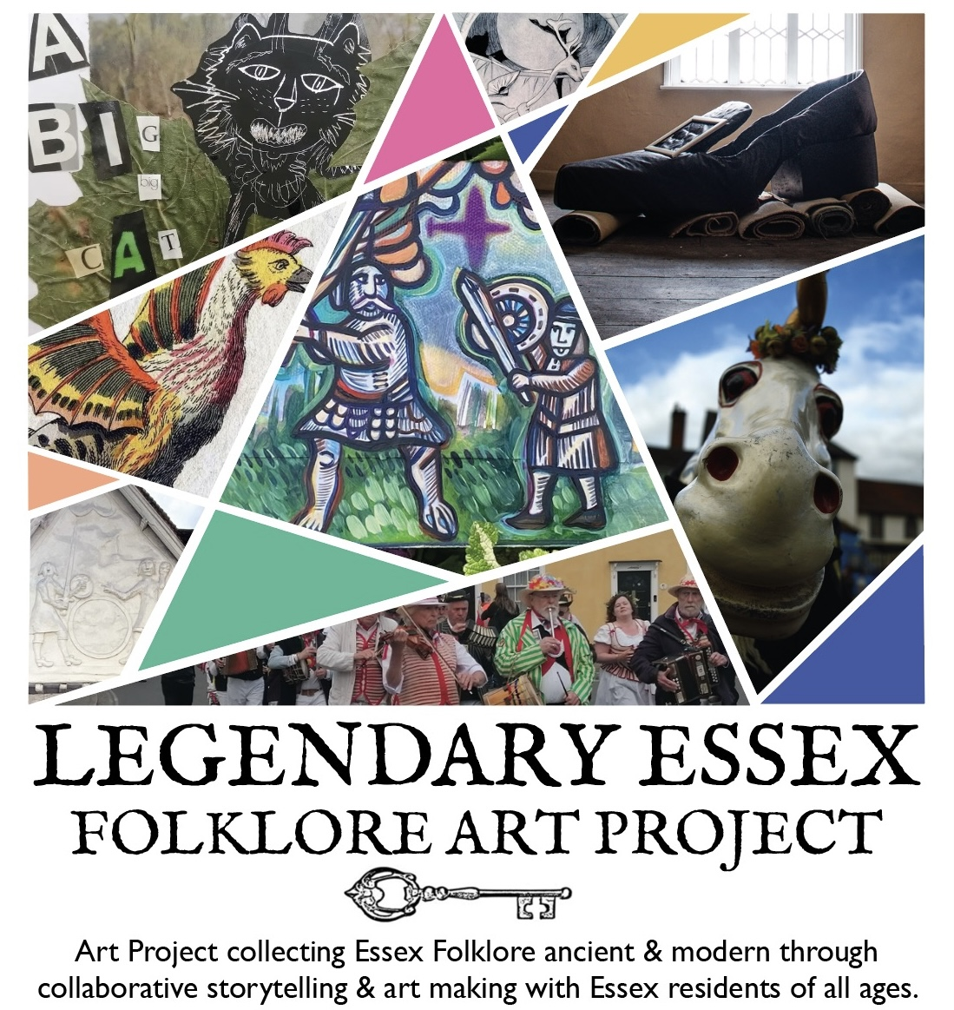

What is Folklore?
Folklore is made up of old stories, traditions, songs, and beliefs passed down through generations. It includes legends, fairy tales, superstitions, and local customs.
These stories often explain the world, share local history, or teach lessons. In Essex, folklore might include tales of witches, haunted places, smugglers, or creatures like the ghostly Black Shuck.
Folklore isn’t always fact, but it shows us what people believed and how they understood their world.
Here are some creative prompts to help you get started with your postcard/artwork. You are also encouraged to share your own unique stories and experiences…
The Black Dog
A ghostly black dog with glowing red eyes is said to haunt the roads and rivers of Essex. It’s most often seen near Tollesbury and is believed to bring a storm—or a warning—when spotted.
The Wormingford Dragon
Legend tells of a dragon that burst from a river in Wormingford and terrorised the village. A brave knight finally defeated it in a fierce battle.
The Essex Serpent
A sea creature was said to rise from the waves after the 1884 Essex earthquake. It inspired stories of mystery, fear—and a famous novel set on the coast.
Boudica the Warrior Queen
Boudica led an army to fight the Romans after they took her land. A statue in Colchester, once the Roman capital, remembers her bravery.
The Curse of the Crooked Cross
A monk insulted a witch in Essex and was cursed. Ever since, the cross he carved always leaned crooked, no matter how it was rebuilt.
Sarah Moore the Sea Witch
Sarah Moore lived by the sea and was feared for her powers. One day, she was blamed for sinking a ship by throwing a storm from the shore.
Borley Rectory
Known as the “most haunted house in England,” Borley Rectory was home to spooky sights: headless ghosts, floating nuns, and eerie sounds.
The Roman Ghost of Mersea Island
People say a Roman soldier marches from a burial mound across the causeway to Colchester. He’s been seen at dusk in full armour, silent and proud.
The Ghost Bride of Canvey Island
A young woman in a wedding dress walks Canvey’s streets, mourning her sailor lost at sea. Her story may have inspired Dickens’ Miss Havisham.
Smugglers and Ghosts
Because of the long coastline there’s a long history of smuggling in the county. Old Essex tales say ghost stories were made up to scare people away from smugglers' secrets.
The Clever Highwayman
Stephen Bunce was a cheeky Essex highwayman. He tricked a nobleman into handing over his horse by pretending to talk to fairies in the forest.
The Blackwater Beast
A beast with the body of a dragon was rumoured to rise from the Blackwater Estuary after an earthquake shook the land and sea.
The White Lady of Hadleigh
At Hadleigh Castle, a woman in white is said to appear when fog rolls in. Some say she’s searching for her lost love—or guarding a secret.
Flying Serpent of Saffron Walden
People claimed to see a flying serpent- so terrifying that the whole area emptied for fear of being cursed.
Witchfinder Matthew Hopkins
Matthew Hopkins hunted witches in Essex. Some people later said he was a witch himself, punished for the pain he caused others.
Saint Osyth and Her Head
Saint Osyth was a Saxon princess beheaded by raiders. Her ghost walks Nuns Wood, holding her head in her hands and glowing in the dark.
Elizabeth I’s Speech at Tilbury
As the Spanish Armada approached, Queen Elizabeth stood in armour and told her troops she had the heart of a king—and they won the battle!
The Dunmow Flitch Trials
In Dunmow, married couples compete to win a side of bacon by proving they haven’t argued for a whole year and a day. The tradition began in 1104!
Enchanted Bluebell Woods
Some say the bluebells in Essex woods are magical. If you hear them ring, you may vanish—and only a trail of petals will remain behind.
The Cunning Man of Hadleigh
James Murrell, born in 1812, was a real Essex “witch doctor.” He used herbs, moonlight, and astrology to heal the sick and protect villagers.
Colchester, Britain’s Oldest Town
Romans called it Camulodunum—It’s the oldest recorded town in Britain.
The Essex Witch Trials
In the 1500s and 1600s, many people—mostly women—were imprisoned and killed in Essex for witchcraft. The first was Elizabeth Lowys in Great Waltham.
Essex’s First Crocodile
In 1701, a man from Braintree brought home the first crocodile in England. He kept it in a lake on his estate—imagine swimming there!
Cheetah Racing in Romford
In the 1930s, Romford tried to race cheetahs at the Greyhound Stadium. But the cheetahs just chased the greyhounds instead of the hare.
Titanic’s Essex Windows
Windows made by Crittall in Braintree were fitted on the Titanic. The factory still makes steel windows used around the world today.
The First Radio Broadcast
In 1920, Chelmsford made history. Dame Nellie Melba sang live on air, making it the world’s first entertainment broadcast.
545 Witchcraft Accusations
Between 1560–1680, 545 people in Essex were accused of witchcraft. Matthew Hopkins alone caused the deaths of around 300 suspected witches.
A Coastline of 350 Miles
Essex’s wiggly coastline is over 350 miles long—longer than the drive from London to Paris! It’s home to 35 different islands.
Southend Pier
Southend Pier is the longest pleasure pier in the world, stretching 1.34 miles. It’s so long it has its own train to take people to the end!
The Mayflower in Harwich
The famous ship that took the Pilgrims to America was built in Harwich. Its captain, Christopher Jones, also came from the town.
King Harold’s Burial
After the Battle of Hastings, King Harold was buried at Waltham Abbey. It’s now one of the best examples of Norman architecture in Britain.
Was Robert the Bruce from Essex?
Some historians say Scottish hero Robert the Bruce was born in Writtle, near Chelmsford, not in Scotland. Imagine that!
Peasants' Revolt Began in Brentwood
In 1381, angry workers in Brentwood stood up to unfair taxes. Their protests spread across England and changed the country forever.
Human History in Essex
Essex has been lived in for thousands of years. People were here in the Stone Age, and it was a major part of Roman Britain too.
UFO Sightings
In the past ten years, police have received 39 reports of UFOs in Essex. The most came from Basildon, but Colchester and Chelmsford weren’t far behind.
The Wonderful Barrel
In 1696, a man from Saffron Walden invented the first hot and cold drinks machine! It was called “The Wonderful Barrel”—very fancy for the time.
@legendaryessex

